

SUKARNA ENGG WORKSContact : 9167318497

SI N C E 1967 Note:

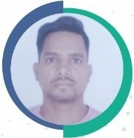

1. This Identity Card is not transferable and it's loss be reported to Office

immediately.

Mr. Rajesh Vishwakarma

Designation : CNC Programer

1. Any one finding the misplaced card is requested to return the same at the Company's address given overleaf.

Email ID : udvadi[a@gmail.com](mailto:a@gmail.com) Add. A-24/G/F, Malad Ind ustrial U nits Co-op Society, Romchondro Lone Extn.,

Kochpoda, Malad (W), Mumbai - 64. I NDIA

Authorised Signatory

 